--------------------------------------------------------------------------------

SQL Server Agent – A First Look

According to Microsoft; “SQL Server Agent is a Microsoft Windows service that executes scheduled administrative tasks, which are called jobs. SQL Server Agent uses SQL Server to store job information. Jobs contain one or more job steps. Each step contains its own task, for example, running an ETL data warehouse load, or backing up a database. SQL Server Agent can run a job on a schedule, in response to a specific event, or on demand. For example, if you want to back up all the company servers every weekday after hours, you can automate this task. Schedule the backup to run after 22:00 Monday through Friday; if the backup encounters a problem, SQL Server Agent can record the event and notify you.” In other words it is a facility that allows processing database tasks as a schedulable item.

🡺 By default, SQL Server Agent is disabled. To enable it, right click on it in the Object Explorer in SSMS and click Start. Once the service has started refresh the server node.

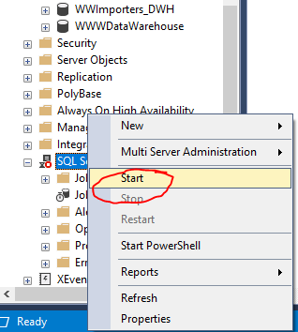

🡺 Next, let’s create our first Job. Expand SQL Server Agent and right click Jobs. Select New Job.

🡺 Give the job a meaningful name and move on to / click on the Steps :

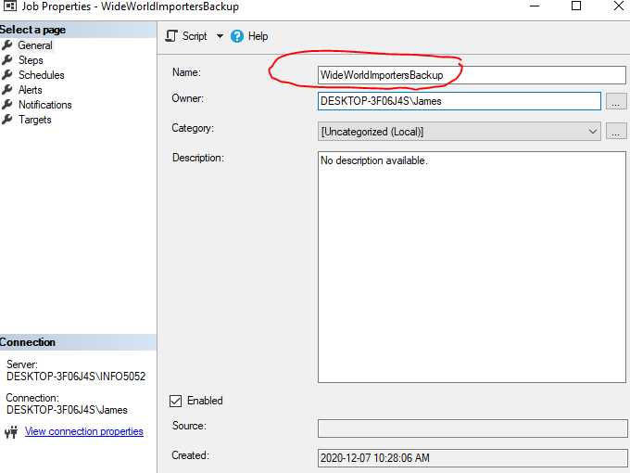

* Under the Steps of the SQL Server Agent Job, **create a New Step** with the T SQL code to perform the backup. Note you would need to rename the Database when you restore it (since you already have a WideWorldImporters database … which is the name it will be restored into). You will need to create a C:\TempDatabaseBackups filefolder if you don’t already have one. Give the SQL Server Agent Job step an appropriate Step name … and include these SQL statements :

Backup Database WideWorldImporters

TO Disk = 'C:\TempDatabaseBackups\WideWorldImportersLT2020.bak'

WITH FORMAT,

MEDIANAME = 'Z_SQLserverBackups',

NAME='Full Backup of WideWorldImportersLT2020' ;

GO

EXEC msdb.dbo.sp_delete_database_backuphistory @database_name =

N'WideWorldImportersLT2020'

GO

--USE [master]

--GO

--DROP DATABASE IF EXISTS [WideWorldImportersLT2020]

--GO

--RESTORE DATABASE WideWorldImportersLT2020

--FROM DISK = 'C:\TempDatabaseBackups\WideWorldImportersLT2020.bak' ;

🡺 If you happen to see this error (can also see this if your SQL server engine is not started/running as well ) :

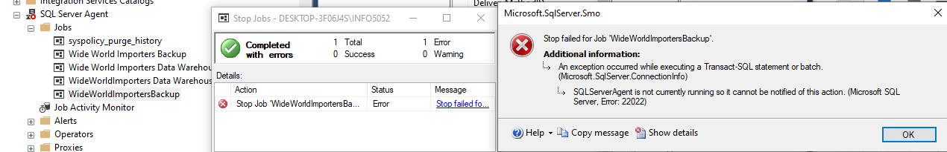

… You need to START your SQL Server Agent service on your PC … so Under Services find your SQL Server Agent and Start this service :

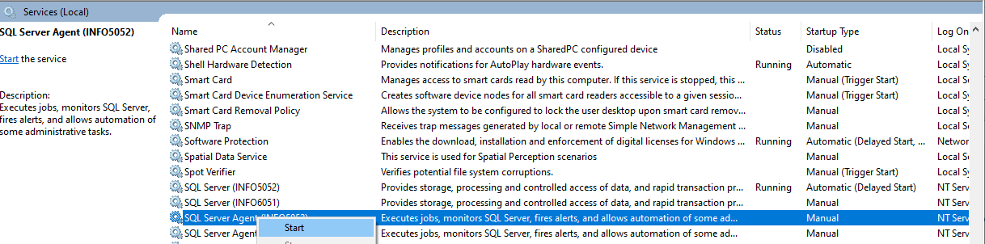

In this way you can:

1. Schedule / Execute and monitor your SQL Server jobs and ensure that your organization is properly protecting your data from loss … or
2. Schedule your ETL Data Mart creation & regular Daily (or Monthly) cycle execution - capturing copies of your OLTP data for use in your Data Warehouse, that those expert Business Analysts can use to predict the future… .